Project Title
Hospital Bed and Operating Room Scheduling
Project Report submitted for the partial fulfilment of grade for the course

Data Structures and Algorithms -3 (25CS2103E)
in

A.Y. 2026-2027

Submitted by
V Vishwa Teja (2520090033)
B Sree Nikhil Reddy (2520090058)

Team Number: 22
Section: 10

Under the guidance of

K. Chandusha

Assistant Professor, CS&IT
Hyderabad-500090, Telangana, India.

K L (Deemed to be) University
DEPARTMENT OF COMPUTER SCIENCE ENGINEERING / COMPUTER SCIENCE AND INFORMATION TECHNOLOGY/ARTIFICIAL INTELLIGENCE & DATA SCIENCE



DECLARATION

The Mini Project Report entitled “Hospital Bed and Operating Room Scheduling
” is a record of Bonafide work of V Vishwa Teja – 2520090033, B Sree Nikhil Reddy – 2520090058. submitted in partial fulfillment for the award of B. Tech in Computer Science and Engineering/Computer Science and Information Technology/ Artifical Intelligence & data Science to the K L University. The results embodied in this report have not been copied from any other departments/University/Institute.

V Vishwa Teja – 2520090033
B Sree Nikhil Reddy – 2520090058

K L (Deemed to be) University
DEPARTMENT OF COMPUTER SCIENCE ENGINEERING / COMPUTER SCIENCE AND INFORMATION TECHNOLOGY
CERTIFICATE

This is to certify that the mini project based report entitled “Hospital Bed and Operating Room Scheduling” is a bonafide work done and submitted by V Vishwa Teja – 2520090033, B Sree Nikhil Reddy – 2520090058. in partial fulfillment of the requirements for the award of the degree of BACHELOR OF TECHNOLOGY in Department of Computer Science Engineering/ Computer Science and Information Technology/Artificial Intelligence & Data Science, K L (Deemed to be University), during the academic year 2026-2027.

Signature of the Supervisor

Signature of the HOD Signature of the External Examiner

ACKNOWLEDGEMENT

The success in this project would not have been possible but for the timely help and guidance rendered by many people. Our wish to express my sincere thanks to all those who has assisted us in one way or the other for the completion of my project.

Our greatest appreciation to my guide, K. Chandusha, Assistant Professor, CS&IT which cannot be expressed in words for his/her tremendous support, encouragement and guidance for this project.

We express our gratitude to Dr. P.Venkateshwar Rao (CSE)/Dr. Khaja Shareef (CSIT)/ Dr. Sreenath Itikela (AI&DS), Head of the Department for Computer Science Engineering/ Department for Computer Science and Information Technology/Department of Artificial Intelligence and Data Science for providing us with adequate facilities, ways and means by which we are able to complete this project-based Lab.

We thank all the members of teaching and non-teaching staff members, and also who have assisted me directly or indirectly for successful completion of this project. Finally, I sincerely thank my parents, friends and classmates for their kind help and cooperation during my work.

V Vishwa Teja – 2520090033
B Sree Nikhil Reddy –2520090058

TABLE OF CONTENTS

S.No. | Contents | Page no.
1. | Abstract | 6
2. | Introduction | 7
3. | Literature survey | 8-10
4. | Problem Statement and Objectives | 11
5. | Hardware and Software requirements | 12
6. | Implementation | 13-18
7. | Results & Discussion | 19-22
8. | Conclusion & Future Scope | 23
9. | References | 24-25

1.ABSTRACT

The Hospital Bed and Operating Room (OR) Scheduling System is a web-based application developed to improve the management of patients, hospital rooms, doctors, and appointments. In hospitals, inefficient patient scheduling and resource allocation can cause delays and make it difficult to manage available rooms and doctor schedules. This project addresses these challenges by applying Data Structures and Algorithms (DSA) to organize patient information and support efficient scheduling. The system uses a Priority Queue to process patients according to their urgency, assigning higher priority to emergency cases. Sorting is used to maintain patient priority order, while linear searching helps identify available rooms and suitable doctors. Arrays and lists store patient details, room information, doctor schedules, and appointments. A greedy-based scheduling approach selects a suitable doctor based on the earliest available time slot and checks whether the appointment duration fits within the doctor's working hours. The application is developed using React.js for the frontend and Node.js with Express.js for the backend. It supports patient registration, room allocation, doctor scheduling, appointment management, dashboard monitoring, and patient discharge. When a patient is discharged, the system marks the appointment as completed, releases the occupied room, and removes the patient from the active doctor schedule. The application uses in-memory data structures without requiring a database. Overall, the project demonstrates the practical application of DSA concepts to hospital resource management and scheduling.
Team Name: Hospital Tech Innovators
Team Members:
- V Vishwa Teja, 2520090033
- B Sree Nikhil Reddy, 2520090058

- INTRODUCTION

In a hospital, every minute matters. When patients arrive with different levels of medical urgency, healthcare staff must make timely decisions about room availability, doctor assignments, and appointment scheduling. Managing these activities manually can become challenging, particularly when emergency cases require immediate attention and hospital resources are limited. An efficient scheduling system can help organize these tasks, reduce scheduling conflicts, and improve the utilization of available hospital resources.
The Hospital Bed and Operating Room (OR) Scheduling System is a web-based application designed to simplify and organize essential hospital scheduling activities. It enables hospital staff to register patients, identify available rooms, assign suitable doctors, schedule appointments, monitor room occupancy, and manage patient discharge. The main goal of this project is to demonstrate how Data Structures and Algorithms (DSA) can be applied to solve real-world resource allocation and scheduling problems through a practical software application.
The system uses a Priority Queue to process patients according to their urgency, ensuring that emergency cases receive higher scheduling priority than high-, normal-, and low-priority cases. Sorting maintains the priority order, while linear searching identifies available rooms and suitable doctors. Arrays and lists organize patient records, room details, doctor schedules, and appointments. A greedy-based scheduling approach selects a suitable doctor with the earliest available time slot, provided the appointment fits within the doctor's working hours.
The application is developed using React.js for the frontend and Node.js with Express.js for the backend. It uses in-memory JavaScript data structures instead of a database, making it suitable for demonstrating the practical implementation of DSA concepts. When a patient is discharged, the system updates the appointment status, releases the occupied room, and removes the patient from the active doctor schedule.
Overall, this project connects theoretical DSA concepts with a practical healthcare management scenario. It demonstrates how appropriate data structures and scheduling techniques can help organize hospital operations and manage resources more systematically. The following sections discuss the literature survey, problem statement and objectives, system requirements, implementation, results and discussion, conclusion, future scope, and references.

- LITERATURE SURVEY

3.1 NextGen eHospital – Hospital Management System
NextGen eHospital is a hospital management system developed by the National Informatics Centre (NIC) in India. It helps hospitals manage patient registration, appointments, admissions, and discharge activities. By keeping hospital information organized, it helps staff handle daily administrative tasks more efficiently. Our project follows a similar goal but focuses more on using Data Structures and Algorithms to prioritize patients and allocate rooms and doctors.
URL: https://nextgen.ehospital.gov.in/

3.2 Patient Prioritization in Operating Room Scheduling
This research focuses on how hospitals can schedule operations based on the priority of patients. It explains why emergency and urgent cases need to be considered carefully when planning operating room schedules. The study also highlights the importance of using available medical resources efficiently. Our project applies a simpler version of this idea by using a Priority Queue to process patients according to their urgency.
URL: https://doi.org/10.1016/j.orhc.2019.100232

3.3 Review of Operating Room Scheduling and Optimization
This study discusses different methods used to plan and organize operating room schedules in hospitals. It explains the challenges involved in assigning patients, managing available rooms, and making the best use of hospital resources. It also shows how scheduling techniques can help reduce delays and improve resource utilization. Our project addresses similar challenges through room allocation and doctor appointment scheduling.
URL: https://link.springer.com/article/10.1007/s12351-024-00884-z

3.4 Healthcare Scheduling and Optimization
This research reviews different scheduling problems in healthcare, including patient appointments, staff scheduling, and operating room management. It explains that proper scheduling is important because hospitals must coordinate many activities with limited resources. The study discusses approaches that can make these processes more organized and efficient. Our project demonstrates these ideas using Priority Queues, sorting, searching, and scheduling logic.
URL: https://pmc.ncbi.nlm.nih.gov/articles/PMC8035616/

3.5 Operating Room Scheduling Based on Patient Priority
This research examines how hospitals can arrange surgical procedures by considering patient priority and the availability of medical resources. It highlights the difficulty of scheduling patients when operating rooms and medical staff have limited availability. The study shows why patient urgency should be considered during scheduling. Similarly, our project processes patients according to priority and assigns available rooms and suitable doctors.
URL: https://opus.lib.uts.edu.au/handle/10453/157364

3.6 Scheduling Surgical Patients Using Priority Lists
This study explores ways to arrange surgical patients in an order that supports efficient use of operating rooms. It considers how the order of patients can affect scheduling decisions and the use of available resources. The research demonstrates the importance of including patient priority in the scheduling process. Our project uses a Priority Queue to maintain patient priority order and support automated scheduling.
URL: https://doi.org/10.1007/s10479-016-2172-x

3.7 Intelligent Operating Room Scheduling System
This research presents an operating room scheduling system designed to improve the way surgeries, rooms, and medical staff are coordinated. It focuses on matching available resources with scheduling requirements. Such systems show how technology can help hospitals organize complex daily operations. Our project follows the same general idea through patient registration, room assignment, doctor scheduling, and appointment management using basic DSA concepts.
URL: https://pmc.ncbi.nlm.nih.gov/articles/PMC13433346/

3.8 Online Tool for Surgery Scheduling and Rescheduling
This research describes an online tool that helps hospitals plan and update surgery schedules using mathematical optimization. It considers factors such as patient priority, surgeon availability, and the efficient use of operating rooms. The study highlights the need for scheduling systems that can organize hospital resources and respond to changing requirements. In comparison, our project uses a Priority Queue and a greedy-based scheduling approach to demonstrate these concepts in a web application.
URL: https://link.springer.com/article/10.1007/s00500-025-10845-z

3.9 Summary of the Literature Survey
The reviewed systems and studies show that patient prioritization, room allocation, doctor availability, and appointment scheduling are important parts of hospital management. Some existing systems manage these activities through complete hospital information platforms, while research studies explore more advanced scheduling and optimization techniques. Our Hospital Bed and Operating Room Scheduling System focuses on applying fundamental DSA concepts to these problems. By using Priority Queues, sorting, linear searching, arrays/lists, and greedy-based scheduling, the project demonstrates how a simple web application can help organize patients, assign rooms, schedule doctors, and manage patient discharge.

- Problem Statement and Objectives

Problem Statement: Hospitals need an efficient way to prioritize patients, assign available rooms and doctors, and schedule appointments based on patient urgency and resource availability.

Problem Description: Managing patients, hospital rooms, and doctor schedules manually can be time-consuming and may lead to delays or confusion. This project uses Data Structures and Algorithms to organize patient priorities, allocate rooms, and schedule appointments more efficiently.

Objectives:
The main objective of this project is to make hospital scheduling simpler, faster, and more organized using DSA concepts.
- Prioritize Patients: Arrange patients according to their urgency using a Priority Queue.
- Assign Hospital Rooms: Identify and allocate available rooms to registered patients.
- Schedule Appointments: Assign doctors and calculate appointment time slots based on their availability.
- Manage Doctor Schedules: Display scheduled appointments and update schedules when patients are discharged.
- Track Room Availability: Release rooms after discharge so they can be assigned to other patients.
- Apply DSA Concepts: Use Priority Queues, sorting, linear searching, arrays, and lists to solve real-world hospital scheduling problems.
- Provide a Simple Interface: Build a user-friendly website where hospital staff can manage patients, rooms, appointments, and dashboard reports.

- HARDWARE AND SOFTWARE REQUIREMENTS
Hardware Requirements:
- Processor: Intel Core i3 or equivalent processor, or higher, to run the application smoothly.
- RAM: Minimum 4 GB RAM; 8 GB is recommended for better performance.
- Storage: At least 500 MB of free storage space for the project files and required tools.
Software Requirements:
- Operating System: Windows 10/11 or Ubuntu Linux.
- Frontend: React.js, HTML, CSS, and JavaScript for developing the user interface.
- Backend: Node.js and Express.js for handling patient registration, room allocation, and appointment scheduling.
- Code Editor and Browser: Visual Studio Code for writing and managing the code, and Google Chrome or Microsoft Edge for running and testing the website.

- IMPLEMENTATION

Module 1: Patient Priority Management
This module gives priority to patients based on their medical urgency. A Priority Queue is used to organize patients, allowing emergency cases to be handled before high-, normal-, and low-priority cases.

// PriorityQueue.js
class PriorityQueue {
constructor() {
this.queue = [];
}

enqueue(patient) {
this.queue.push(patient);
this.queue.sort((a, b) => a.priority - b.priority);
}

dequeue() {
return this.queue.shift();
}

peek() {
return this.queue[0];
}

isEmpty() {
return this.queue.length === 0;
}
}

module.exports = PriorityQueue;
Explanation: The queue arranges patients according to their priority number. For example, a patient with priority 1 is placed before a patient with priority 3.

Module 2: Hospital Room Allocation
This module checks room availability and assigns an available room to a patient. Once a room is assigned, its status changes to occupied. This helps staff identify which rooms are available for incoming patients.

// Room.js
class Room {
constructor(id, roomNumber, type) {
this.id = id;
this.roomNumber = roomNumber;
this.type = type;
this.status = "Available";
this.patient = null;
}

assignPatient(patient) {
if (this.status === "Available") {
this.patient = patient;
this.status = "Occupied";
return true;
}

return false;
}

releaseRoom() {
this.patient = null;
this.status = "Available";
}

getDetails() {
return {
id: this.id,
roomNumber: this.roomNumber,
type: this.type,
status: this.status
};
}
}

module.exports = Room;
Explanation: The assignPatient() method assigns a patient when the room is available. The releaseRoom() method makes the room available again after the patient is discharged.

Module 3: Doctor and Appointment Scheduling
This module helps assign doctors and schedule appointments based on their available time. The scheduler considers the appointment duration and the doctor's working hours to find a suitable time slot.

// Scheduler.js (illustrative scheduling logic)
function scheduleAppointment(doctor, appointment) {
const startTime = doctor.schedule.length
? doctor.schedule[doctor.schedule.length - 1].endTime
: doctor.startTime;

const [startHour, startMinute] = startTime
.split(":")
.map(Number);

const totalMinutes =
startHour * 60 + startMinute + appointment.duration;

const endHour = Math.floor(totalMinutes / 60);
const endMinute = totalMinutes % 60;

const endTime =
String(endHour).padStart(2, "0") + ":" +
String(endMinute).padStart(2, "0");

if (totalMinutes > 24 * 60) {
return false;
}

appointment.startTime = startTime;
appointment.endTime = endTime;

doctor.schedule.push(appointment);
return true;
}
Explanation: This example calculates an appointment's start and end times and adds it to the doctor's schedule. In the project, the scheduling logic should also respect the doctor's actual working-hour limits. Use the corresponding implementation from your Scheduler.js file if its logic differs from this simplified example.

Module 4: Patient Discharge and Room Release
This module manages the discharge process. When a patient is discharged, the appointment is marked as completed, the assigned room is released, and the appointment is removed from the doctor's active schedule.

// Discharge handling logic
if (appointment) {
appointment.status = "Completed";

const doctor = doctors.find(
d => d.id === appointment.doctor.id
);

if (doctor) {
doctor.schedule = doctor.schedule.filter(
a => a.id !== appointment.id
);
}
}
Explanation: The system updates the appointment status and removes the completed appointment from the doctor's active schedule. The room is also released through the project's room-release logic, making it available for another patient.

Implementation Summary
These four modules demonstrate how the project uses Data Structures and Algorithms to solve practical hospital scheduling problems. The Priority Queue manages patient urgency, arrays and sorting organize records, linear searching helps locate doctors or rooms, and scheduling logic manages appointments and resource availability.

- RESULTS & DISCUSSION
The Hospital Bed and OR Scheduling System was successfully developed to make patient management and hospital scheduling easier. The following screenshots show the main features of the application and how they work.

1. Dashboard
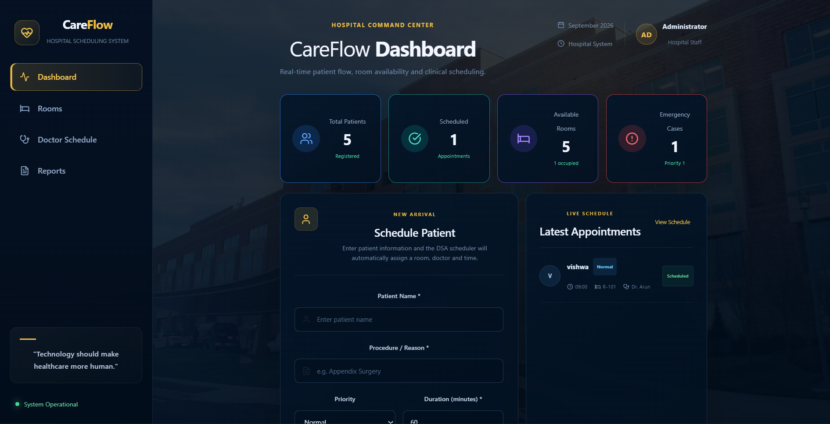
The dashboard provides an overview of the hospital's current activities, including patient details, room availability, and scheduling information. It helps hospital staff quickly understand the overall status of the system.

2. Patient Management
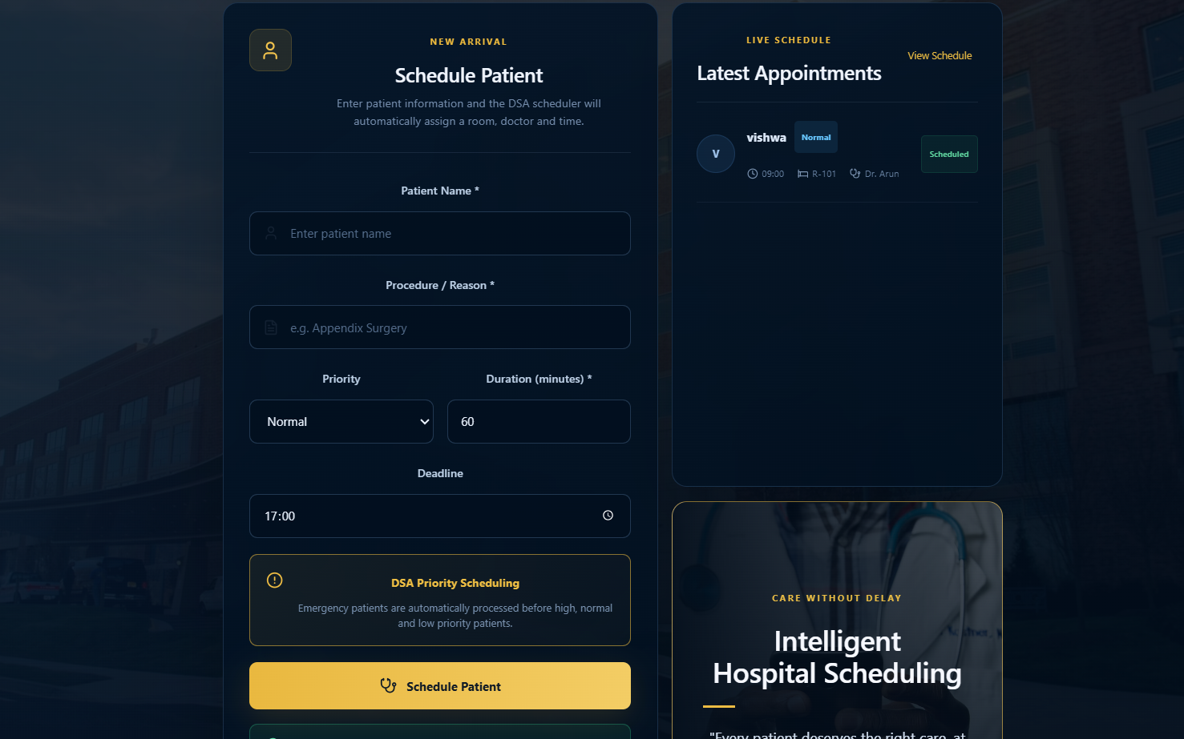
This page allows hospital staff to register patients and enter details such as their name, priority, and procedure or reason for admission. These details help the system organize patients and manage their scheduling.

3. Room Management
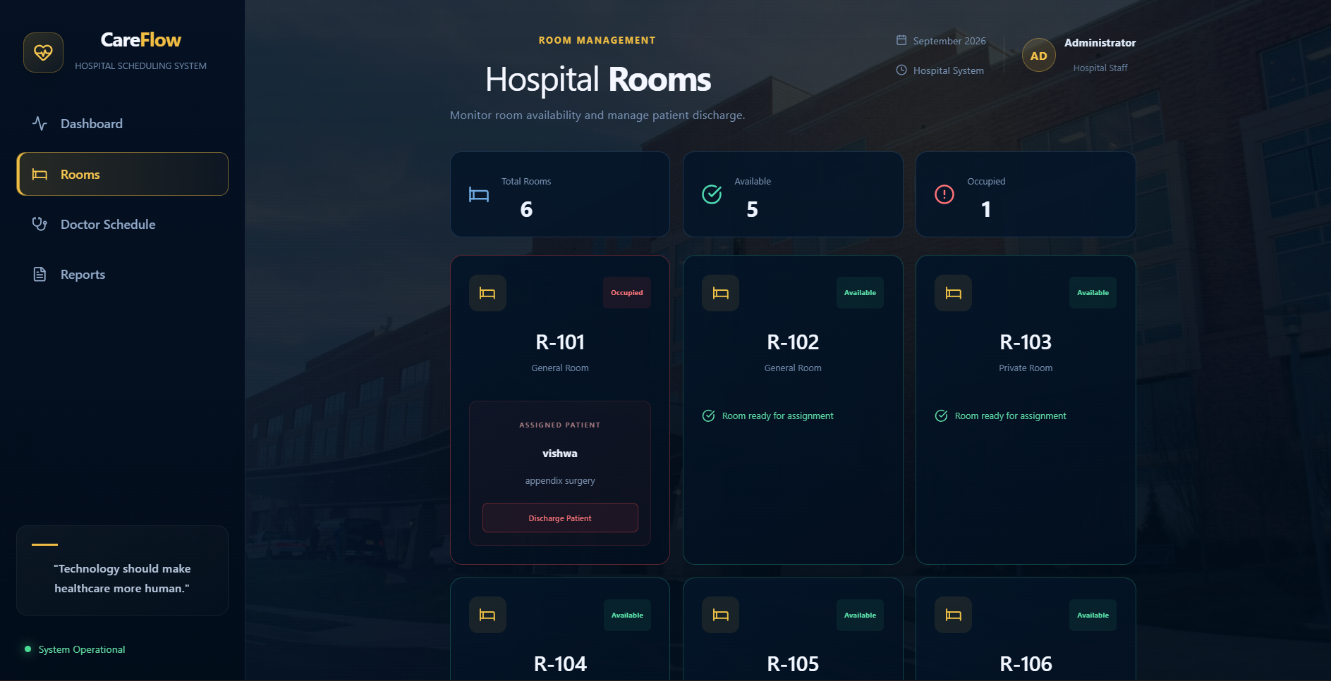The room management page displays the available and occupied hospital rooms. When a patient is assigned to a room, its status is updated, and the room can be made available again after discharge.

4. Doctor and Appointment Scheduling
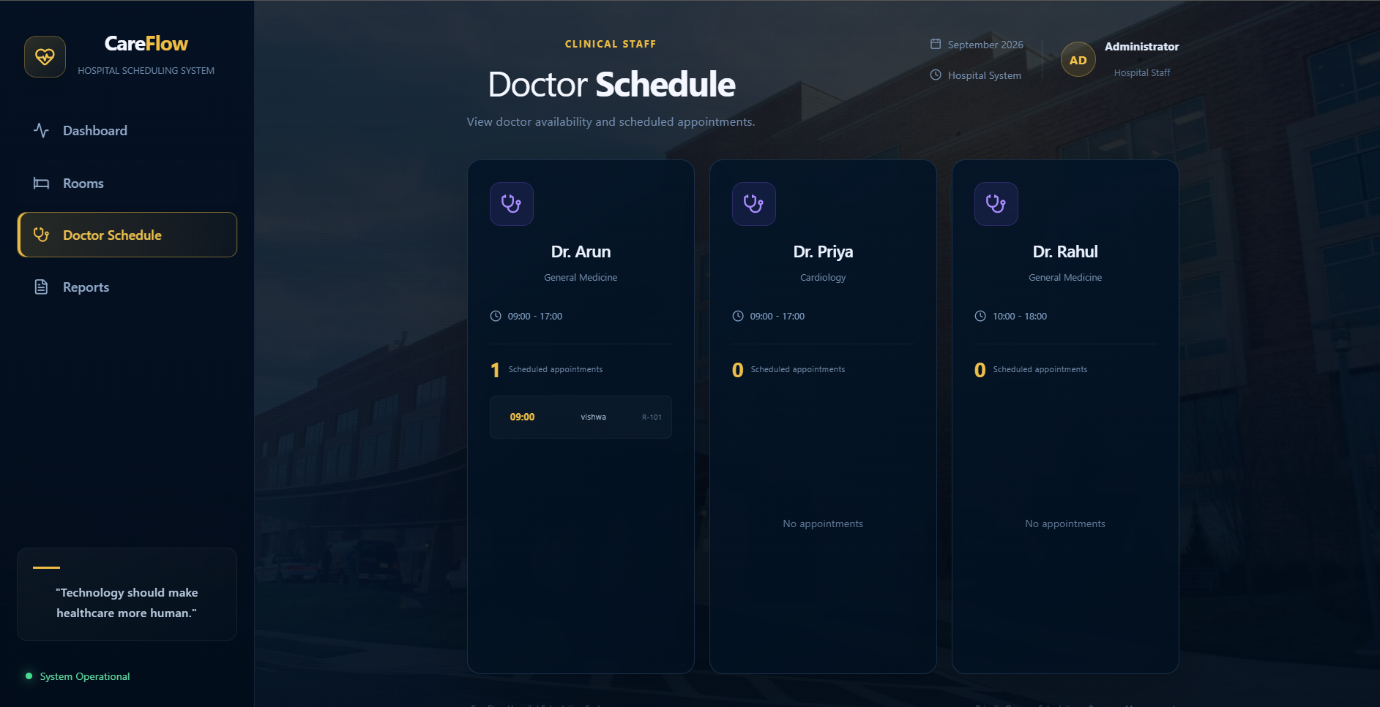
This module helps assign doctors and arrange appointment time slots according to the scheduling logic and doctor availability. It makes the appointment process more organized and reduces the need for manual scheduling.
5. Patient Discharge
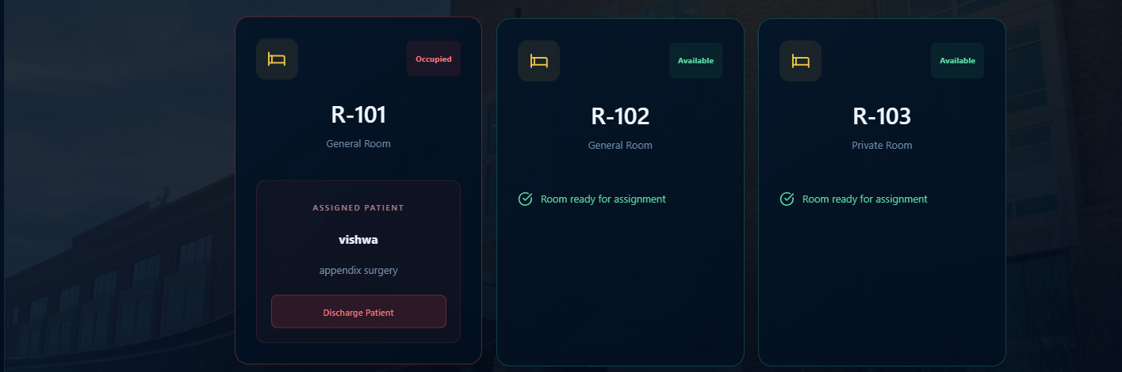When a patient is discharged, the appointment is marked as completed and the room is released for future use. The completed appointment is also removed from the doctor's active schedule.

- CONCLUSION & FUTURE SCOPE

Conclusion:
The Hospital Bed and OR Scheduling System was developed to make hospital patient management and scheduling easier and more organized. The project achieves its main objectives by helping staff manage patient priorities, assign available rooms, schedule doctors, and handle patient discharge. By applying Data Structures and Algorithms such as Priority Queues, sorting, linear searching, arrays, and lists, the project demonstrates how programming concepts can solve real-world problems. Overall, this project helped us understand the practical use of DSA in building a useful web application.

Future Scope:
The project can be improved further by adding more features in the future.
1. Short-Term Improvements
- Improve the user interface and make it easier for hospital staff to use.
- Add better validation for patient details, room allocation, and appointment timings.
- Improve scheduling to consider doctor specializations and room types.
2. Medium-Term Improvements
- Add a database to store patient, room, and appointment records permanently.
- Introduce notifications and reminders for upcoming appointments.
- Generate detailed reports on room occupancy, patient priorities, and doctor schedules.
3. Long-Term Improvements
- Develop a system that can manage multiple hospital departments.
- Explore advanced scheduling algorithms to improve resource allocation.
- Add secure staff login and role-based access to protect patient information.

- REFERENCES

1. React Documentation. React – Official Documentation. Available at: https://react.dev/learn
2. Node.js Documentation. Node.js – Official Documentation. Available at: https://nodejs.org/docs/latest/api/
3. Express.js Documentation. Express – Web Application Framework for Node.js. Available at: https://expressjs.com/
4. MDN Web Docs. JavaScript Array.prototype.sort(). Available at: https://developer.mozilla.org/en-US/docs/Web/JavaScript/Reference/Global_Objects/Array/sort
5. MDN Web Docs. JavaScript Array.prototype.find(). Available at: https://developer.mozilla.org/en-US/docs/Web/JavaScript/Reference/Global_Objects/Array/find
6. MDN Web Docs. JavaScript Array.prototype.filter(). Available at: https://developer.mozilla.org/en-US/docs/Web/JavaScript/Reference/Global_Objects/Array/filter
7. Operating Room Planning and Scheduling for Outpatients and Inpatients: A Review and Future Research. Operations Research for Health Care, 2021. Available at: https://doi.org/10.1016/j.orhc.2021.100323
8. A Comprehensive Review on Operating Room Scheduling and Optimization. Operational Research, Springer. Available at: https://link.springer.com/article/10.1007/s12351-024-00884-z
9. Assessing the Impact of Patient Prioritization on Operating Room Schedules. Operations Research for Health Care. Available at: https://www.sciencedirect.com/science/article/abs/pii/S2211692318301590
10. Express.js Documentation. Routing Guide. Available at: https://expressjs.com/en/guide/routing/

